****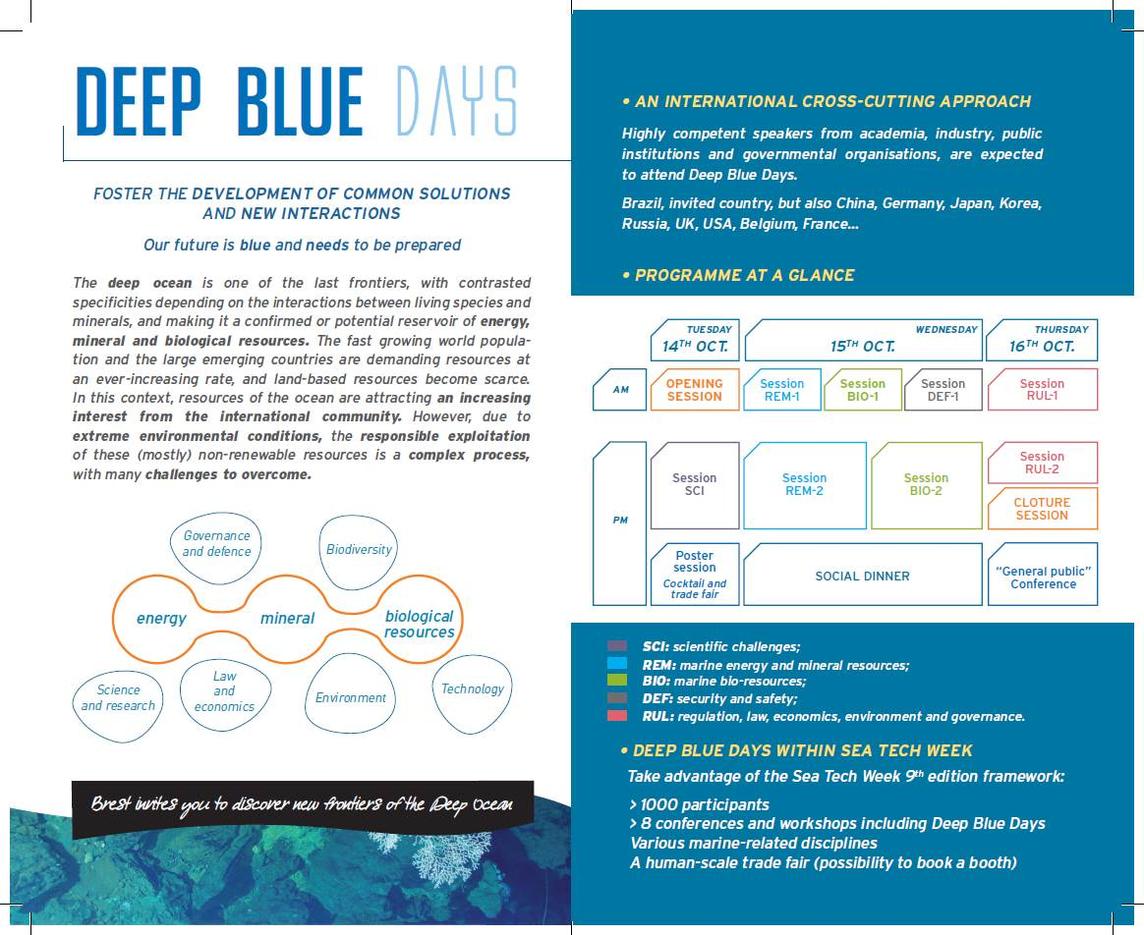

**Discount registration form**

Provided by:

**Personal details**

One form per person / Please complete in capital letters

|  |  |
| --- | --- |
|  | |
| Name | |
|  | |
| First name | |
|  | |
| Company | |
|  | |
| Invoicing address | |
|  |  |
| Postal code | City |
|  | |
| Country | |
|  |  |
| Telephone | Mobile |
|  | |
| Email | |

**Lunches and evenings**

Book the lunches and social events you will attend (Tick your choice)

|  |  |  |  |
| --- | --- | --- | --- |
| Lunches at the Congress Centre: | | | |
| Tuesday 14October: |  | (25€) | |
| Wednesday 15 October: |  | (25€) | |
| Thursday 16 October: |  | (25€) | |
| Cocktail at Oceanopolis on Tuesday 14 October: | |  | (included) |
| Social dinner including the Ibrahim Maalouf’s show*  at the Quartz Congress Centre on Wednesday 15 October: (*http://www.ibrahimmaalouf.com/en/) | |  | (35€) |

**14 > 16 October 2014, Brest, France,** Le Quartz Congress Centre

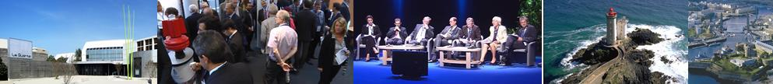 

|  |  |
| --- | --- |
|  | *(Please complete)* |
| **Discount registration fees :**  Discount regular : 180 € (instead of 250€)  Or Student : 100€ (upon appropriate justification) |  |
| **Total lunches and evenings :** |  |
| **GLOBAL TOTAL :** |  |

Follow Deep Blue Days on Twitter **@DeepBlueDaysSTW**

Interested in the other Sea Tech Week events? Info and registration at [**www.seatechweek-brest.org**](http://www.seatechweek-brest.org)

**Registration form to return to   
Juliette Rimetz-Planchon before 10th September 2014**[**Juliette.rimetz@tech-brest-iroise.fr**](mailto:Juliette.rimetz@tech-brest-iroise.fr)

**You will then receive the invoice from Le Quartz Congress Centre by email**

Registration fees include:

* Access to the conference Deep Blue Days;
* Access to the trade fair;
* Possibility to participate to BtoB meetings;
* Coffee breaks;
* Cocktail at Oceanopolis;
* Badges, conference booklet and rucksack.

Registration does not include lunches and social dinner.

**Contact :**

**Juliette Rimetz-Planchon, Technopôle Brest-Iroise**

[**Juliette.rimetz@tech-brest-iroise.fr**](mailto:Juliette.rimetz@tech-brest-iroise.fr)